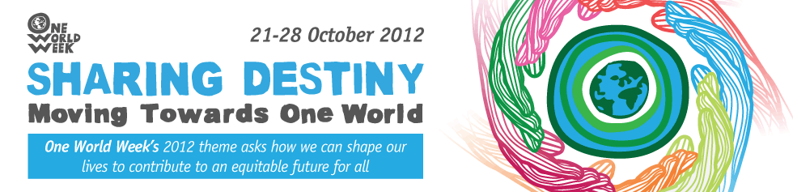

Sharing Destiny Quotations

Introduction:
How could you use these quotations?
- To stimulate thinking - you could select individual quotations, enlarge them and print them off – then put them in eye-catching positions around your event:

  - on tables if you are having a meal;
  - on seats for a presentation;
  - on the wall, if people are circulating;
  - include them in displays;
  - include appropriate ones in an interfaith event or worship;
  - give one to everyone as they come into the event. (Follow up by inviting them to sign up to a pledge later in the event or as they leave – see Sharing Destiny Pledges).

- As part of your publicity – choose pithy arresting ones to catch the interest!

- As part of a discussion activity- give one to everyone or, if people are sitting round a table, let people choose one they like. Invite them to share it with the others and initiate a discussion about the implications for how we might change the way we live. You could use this together with the Sharing Destiny Pledges.

- Your ideas – we would love you to share your ideas about how to use quotations with other OWW organisers. Contact us and we’ll put them on the website.

The quotations
We found the following quotations from various sources, as indicated- from websites, publications and reports.
You will probably know lots more. Please tell us about your favourites – with sources if possible and we’ll include some of them on the website or use them to update this list.

Quotes from: http://www.quotegarden.com/environment.html

“Because we don't think about future generations, they will never forget us.”
(Henrik Tikkanen)

“If we don’t learn to live together as brothers and sisters, we will die together as fools”
(Martin Luther King)

“We do not inherit the earth from our ancestors; we borrow it from our children.”
(Native American Proverb)

“We abuse land because we regard it as a commodity belonging to us. When we see land as a community to which we belong, we may begin to use it with love and respect.”
(Aldo Leopold, A Sand County Almanac.)
“The earth we abuse and the living things we kill will, in the end, take their revenge; for in exploiting their presence we are diminishing our future.”
(Marya Mannes, More in Anger, 1958)

“Economic advance is not the same thing as human progress.”
(John Clapham, A Concise Economic History of Britain, 1957)

“I conceive that the land belongs to a vast family of which many are dead, few are living, and countless numbers are still unborn.”
(Author Unknown)

“Humankind has not woven the web of life. We are but one thread within it. Whatever we do to the web, we do to ourselves. All things are bound together. All things connect.”
(Chief Seattle, 1855)
“When one tugs at a single thing in nature, he finds it attached to the rest of the world.”
(John Muir (founder of the conservation movement)

“Man's heart away from nature becomes hard; lack of respect for growing, living things soon leads to lack of respect for humans too.”
(Chief Luther Standing Bear (paraphrased)

Quotes from UN Environmental Conference at Durban, RSA. November 2011

“Save our tomorrow – today.”
(Quoted from the slogan under which the Cayman Islands Marine Parks were established in 1986)

“We have stolen the Earth from our children.” (Jane Goodall)

“Ordinary people can achieve extraordinary things if we have big dreams. Faith is believing in what we cannot yet see. Our planet is ill and it is up to us to heal her.”
(Braam Malherbe, who ran the length Great Wall of China.)

“We have only one home… Whether you are rich or poor, this is our only home. … Now we are saying we want to move together to a world that is our home, that is a garden. We are meant to live together harmoniously as members of one family, God’s family. There is only one race on earth, the human race, [we should] care for each other as members of a family.”
(Archbishop Desmond Tutu)

“We in the faith communities know that we need a paradigm shift that puts people and planet before profit. We call for a renewed moral and spiritual vision for the future of humanity and all life.
In our world today we have some people who have huge sums of money while millions don’t have food or clean water. This is an affront to God. We are paying the price, with violence and conflict and the destruction of our planet – our only home.
We must move away from the relentless pursuit of economic growth and wealth, to the well-being of people and planet. This means a radical change from our unequal and wasteful lifestyle. Ethics before Economics.”
(Bishop Geoff Davies, Executive Director,

Southern African Faith Communities’ Environment Institute)

“Every single thing in existence is worthy of supreme reverence. Nature is not something for human beings to exploit as they see fit, solely for their own interests. Both nature and humanity are part of, and complete expressions of, the life of the universe.”
(Loren Braithwaite Kabosha, (Buddhist) Soka Gakkai International – South Africa)
From the Earth Charter
“We stand at a critical moment in Earth's history, a time when humanity must choose its future.”

“To move forward we must recognize that in the midst of a magnificent diversity of cultures and life forms we are one human family and one earth community with a common destiny.”

“...it is imperative that we, the peoples of Earth, declare our responsibility to one another, to the greater community of life, and to future generations.”

From the One World Almanac 2012 (Published by New Internationalist)
“Grass does not grow by tugging at its blades but by watering its roots.” (African proverb)

“There is a journey,

And who is for the long road
Loves not to linger.” (EE Cummings, US poet 1894 – 1962)

“The future has several names. For the weak, it is the impossible. For the fainthearted, it is the unknown. For the thoughtful and valiant, it is the ideal.” (Victor Hugo)

“Unless we change direction, we are likely to end up where we are going.” (Chinese proverb)

“Our greatness lies not so much in being able to remake the world ... as in being able to remake ourselves.”
(Mohandas Karamchand Gandhi - 1869-1948)

“We find an appetite for a public debate which can reflect both our hopes and our fears, about who we are, how we got here, and how we can create the future that we want to share.”
(Sunder Katwala, director, British Future)

Other Sources
“Hope has two beautiful daughters: their names are anger and courage. Anger that things are the way they are. Courage to make them the way they ought to be.”
(St Augustine of Hippo)

"Allah does not change the condition of a people until they change themselves" (Qur'an 13:11)

“Farm as if you’ll live forever; live as if you’ll die tomorrow”
(North African Proverb, but similar versions exist in many cultures)

